**ENVIRONMENTALMONITORING**

**TeamMembers:**

**912221104036 - Rajasekar M**

**912221104304 – Kavinraj M**

**912221104702 – Deepan Kumar S**

**912221104030 – Mahaprabu K**

**912221104034 – Prakash K**

**Phase 5: Project Documentation & Submission**

**Environmental Monitoring**

**ABSTRACT:**

Environmental monitoring is a crucial process for assessing, understanding, and managing the impact of human activities on the natural world. This abstract provides an overview of the purpose, methods, and significance of environmental monitoring in safeguarding ecosystems, biodiversity, and human health. The primary goal of environmental monitoring is to collect and analyze data on various environmental parameters, such as air and water quality, soil health, biodiversity, and climate patterns. This data serves as a foundation for evaluating the health of ecosystems and detecting changes over time. It involves the use of advanced technologies, including remote sensing, sensor networks, and geographic information systems (GIS), enabling the continuous collection of data across diverse geographical areas.

**INTRODUCTION:**

Environmental monitoring is the systematic process of observing, assessing, and managing the conditions and quality of the environment. It involves the collection of data to understand changes in environmental parameters such as air, water, soil quality, biodiversity, and other natural resources. The primary objectives of environmental monitoring are to track changes in the environment, identify potential risks or threats to ecosystems and human health, and inform decision-making for conservation and sustainable resource management

**LITERATURE REVIEW:**

The field of environmental monitoring plays a pivotal role in comprehending, managing, and safeguarding our ecosystems, addressing the repercussions of human activities on the natural world. Historically, the evolution of environmental monitoring has been shaped by legislative milestones, scientific advancements, and societal awareness. Methodologies have evolved from traditional sampling and laboratory analysis to encompass innovative technologies like remote sensing, GIS, and IoT, enabling a more comprehensive and real-time understanding of environmental dynamics. Monitoring key parameters—such as air and water quality, soil conditions, biodiversity, and climate change indicators—provides critical insights into the health and resilience of our planet. This monitoring is not just theoretical but finds practical applications in diverse fields, from public health, industrial compliance, and disaster management to ecological preservation and policy formulation. However, despite its immense significance, environmental monitoring faces challenges —interpretation of data, technological limitations, and resource constraints. Embracing emerging technologies like AI and machine learning presents promising opportunities for more robust and efficient monitoring. The continual refinement of environmental monitoring practices is crucial for informed decision-making and the sustainable stewardship of our planet, setting the trajectory for future environmental policies and actions.

**WORKING PRINCIPLE:**

Environmental monitoring involves the systematic collection of data to observe and analyze various aspects of the environment. It is crucial for understanding changes in environmental conditions, detecting pollution, assessing ecological impacts, and making informed decisions about environmental management and conservation. The working principle of environmental monitoring typically involves several key steps:

**1. Defining Objectives:** Establish clear goals and objectives for the monitoring process. This could include studying air quality, water quality, soil health, biodiversity, climate change impacts, or other specific environmental factors.

**2. Selection of Parameters:** Identify the specific parameters or indicators to be measured. These could be physical (temperature, humidity), chemical (pollutants, pH levels), or biological (biodiversity, species population).

**3. Site Selection:** Determine the locations (sites) for monitoring. These sites should be representative of the area being studied and should provide meaningful data for analysis.

**4. Data Collection:** Use appropriate instruments and methods to collect data. This could involve the deployment of sensors, sampling equipment, remote sensing technologies, or manual observations.

**5. Data Analysis:** Process and analyze the collected data to understand trends, patterns, and changes in the environment. Statistical analysis and modeling may be used to interpret the data effectively.

**6. Interpretation and Reporting:** Interpret the analyzed data to draw conclusions about the state of the environment. Create reports that communicate findings and recommendations to stakeholders, policymakers, or the public.

**7. Action and Management:** Use the gathered information to make informed decisions about environmental management, policy-making, and interventions. This may involve implementing measures to mitigate pollution, conserve resources, or adapt to environmental changes.

**8. Continuous Monitoring and Feedback:** Environmental monitoring is an ongoing process. Continuous data collection and periodic reassessment are essential to track changes over time, allowing for adaptive management strategies.

Various technologies are used in environmental monitoring, including satellite remote sensing, unmanned aerial vehicles (drones), IoT (Internet of Things) sensors, data loggers, and traditional manual methods. These technologies aid in collecting vast amounts of data efficiently and accurately.

Environmental monitoring is interdisciplinary, involving fields such as environmental science, ecology, meteorology, geology, chemistry, and more. Its primary aim is to provide comprehensive and accurate information for better decision-making and sustainable environmental management.

**ARCHITECTURE OF THE PROPOSED SYSTEM:**

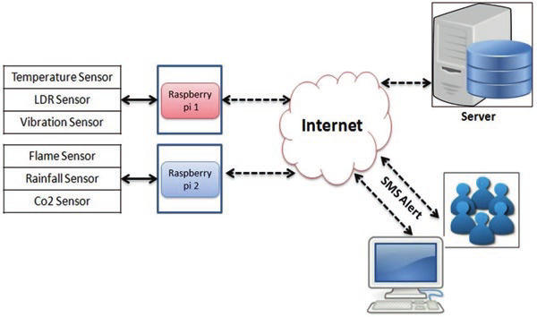

**HARDWARE REQUIREMENTS:**

1. Temperature sensors

2. Humidity sensors

3. Air quality sensors

4. Water quality sensors

5. Power supply

6. Data Loggers

7. Battery

8. Solar Panels

9. Mains Power

10. Calibration and Maintenance Tools

11. Security Measures

**SOFTWARE REQUIREMENTS:**

1. Data Collection and Integration

2. Visualization and Reporting

3. Data Analysis and Modeling

4. Data Storage and Management

**BLOCK DIAGRAM:**

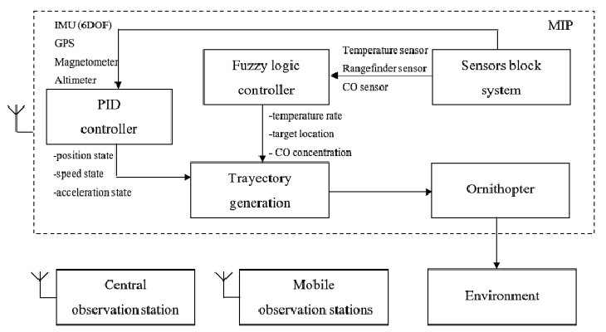

**WORKING MODEL:**

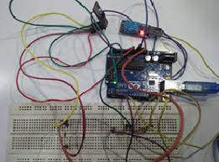

**ADVANTAGES:**

1. Early Warning System

2. Data-Driven Decision Making

3. Ecosystem Health Assessment

4. Climate Change Mitigation and Adaptation

**DISADVANTAGES:**

1. Potential Overreliance on Data

2. Maintaining Monitoring Systems can be expensive

3. Limited Coverage and Accessibility

4. Technological Limitations

**CODING:**

import random

import time

# Function to simulate air quality data from a sensor

def get_air_quality_data():

# Simulate air quality data (replace this with actual sensor data)

air_quality = random.uniform(0, 100)

return air_quality

# Function to process the collected data

def process_data(air_quality):

# Replace this with your actual data processing logic

if air_quality < 50:

return "Good air quality"

elif air_quality < 75:

return "Moderate air quality"

else:

return "Poor air quality"

# Main function to continuously monitor air quality

def monitor_air_quality():

while True:

air_quality = get_air_quality_data()

status = process_data(air_quality)

timestamp = time.strftime('%Y-%m-%d %H:%M:%S')

print(f"At {timestamp}, Air Quality: {air_quality:.2f} - {status}")

time.sleep(5) # Change the interval as needed

# Run the monitoring function

monitor_air_quality()

**CONCLUSION:**

Environmental monitoring is a fundamental tool that serves as the guardian of our planet's health. Through meticulous data collection, analysis, and interpretation, it offers invaluable insights into the intricate dynamics of our ecosystems. By assessing the quality of air, water, soil, and biodiversity, monitoring initiatives provide a holistic view of the environment's well-being. These efforts highlight the interplay between human activities, climate shifts, and natural occurrences, allowing us to gauge their impacts on nature. Crucially, the data derived from these monitoring programs serve as the cornerstone for developing policies, regulations, and strategies aimed at preserving and managing our environment sustainably. Moreover, environmental monitoring acts as an early warning system, signaling potential environmental risks, thereby enabling timely interventions to prevent or mitigate adverse outcomes. By sharing these findings with the public, it not only raises awareness but also fosters a collective responsibility towards environmental stewardship. The continuous feedback loop established through monitoring ensures adaptive and effective management strategies for the ongoing preservation of our planet. In conclusion, the vigilance and insights provided by environmental monitoring are pivotal in shaping our understanding of, and proactive response to, environmental challenges, ultimately securing the well-being of our ecosystems for generations to come.